**Collection Framework Assignment-1**

1. Write a program to calculate the Simple Interest with minimal code using features of Java 11.

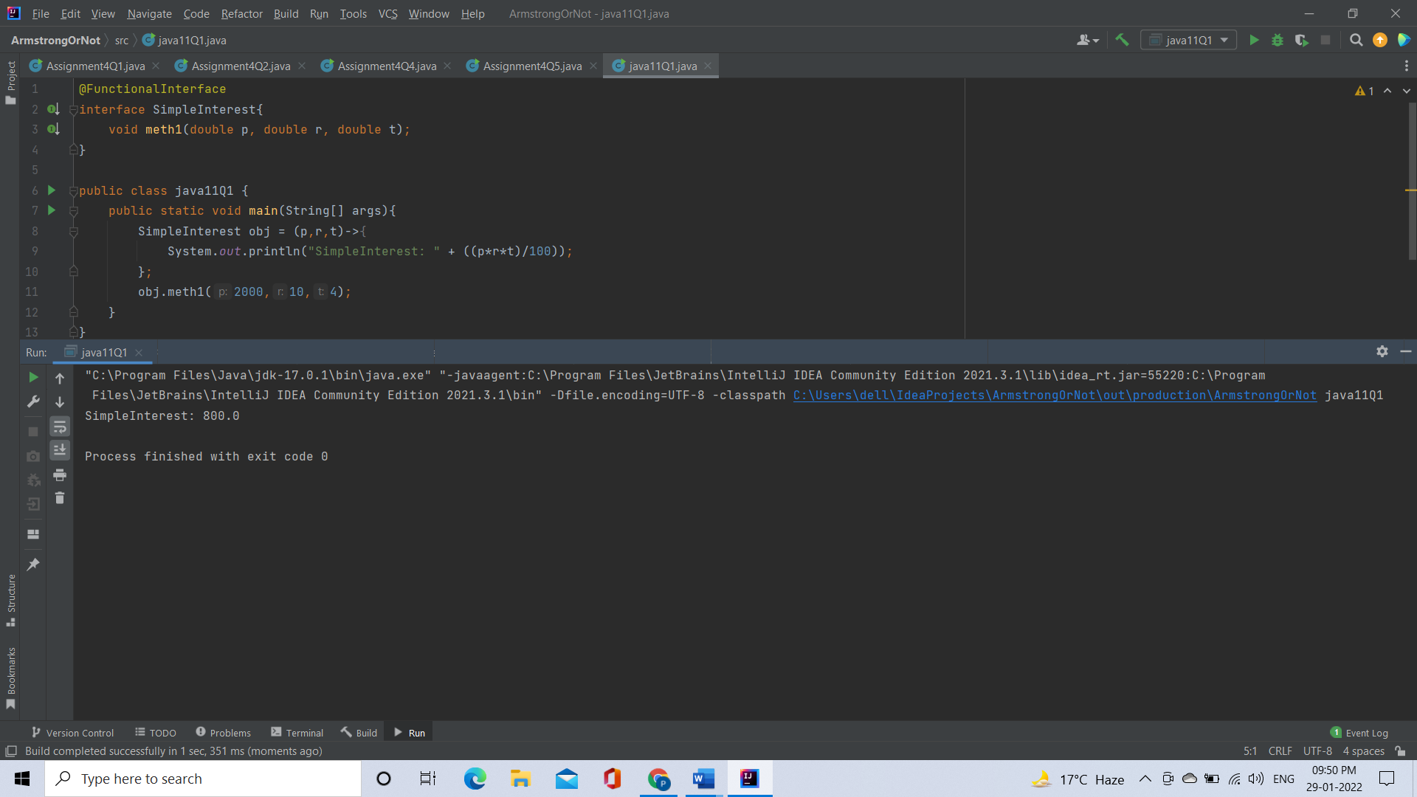

2. Java 11 supports var keyword for variable declarations. List the scenarios where var keyword cannot be used for such variable declarations. Give reason in support of your answer for each scenario.

**Answer:**

scenarios where var keyword cannot be used are:

* **var cannot be used for method parameters and return type**
* **var cannot be used with Lambda Expression.**

3. “A quick brown fox jumps over the lazy dog”. Create an ArrayList from the given String. Such an ArrayList should include each word from the given sentence. Finally convert such List to an array using Java 11 methods and print the output.

